1. System Architecture Overview
The system consists of three major components:
IoT Layer: Raspberry Pi device with sensors or data-collecting scripts
Communication Layer: PubNub real-time messaging network
Web Application Layer: AWS-hosted web server and database

2. Architecture Diagram (Text Version You Can Copy Into Your Report)
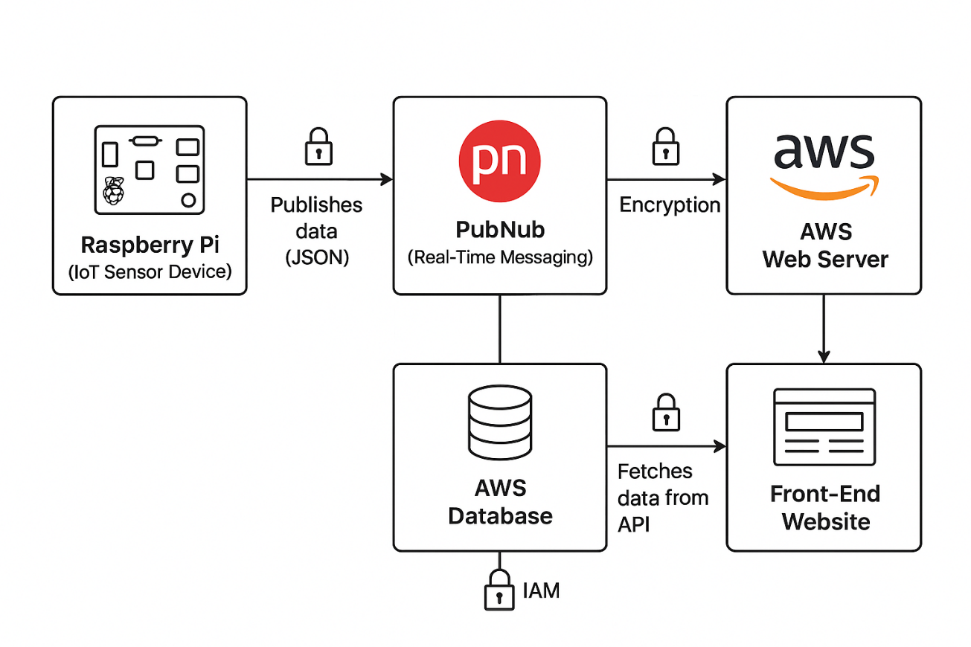
3. Data Flow Explanation
Data Generation (IoT Layer)
The Raspberry Pi collects sensor readings or system information.
These values are packaged into a JSON message.
Data Transmission via PubNub (Communication Layer)
The Pi publishes the data to a secure PubNub channel.
PubNub delivers the message in real time to all subscribed clients, including the AWS server.

Data Processing on AWS (Web Server Layer)
The AWS EC2 application subscribes to the PubNub channel.
Whenever new data arrives, the server:
Parses the message
Validates it
Stores the data into the database
Makes it available through a WebSocket endpoint
Storage (Database Layer)
Data is written into an AWS database such as RDS (MySQL/PostgreSQL) or DynamoDB.
The database stores historical sensor readings for retrieval by the website.
Output (Front-End Layer)
The website calls the AWS API.
It fetches the latest sensor info from the database and displays it to the user.

4. Security Measures
Your system secures data while it is moving using:
TLS/SSL encryption on:
PubNub channels (PubNub enforces secure connections)
HTTP requests between the website and the AWS server
Database connections (RDS supports SSL)
This prevents eavesdropping and man-in-the-middle attacks.
Data at Rest
Data stored on servers or databases is protected using:
AWS-managed encryption at rest
IAM roles and policies to restrict database access
Firewall/security groups controlling which IPs can reach the server
Together, these ensure that even if a storage system is compromised, the data cannot be read.

